

Submitted by: Muqadas Nawaz
Submitted to: Mam Nayab Khalid
Sap id: 73671
Subject: data structure and algorithm

Task 01:

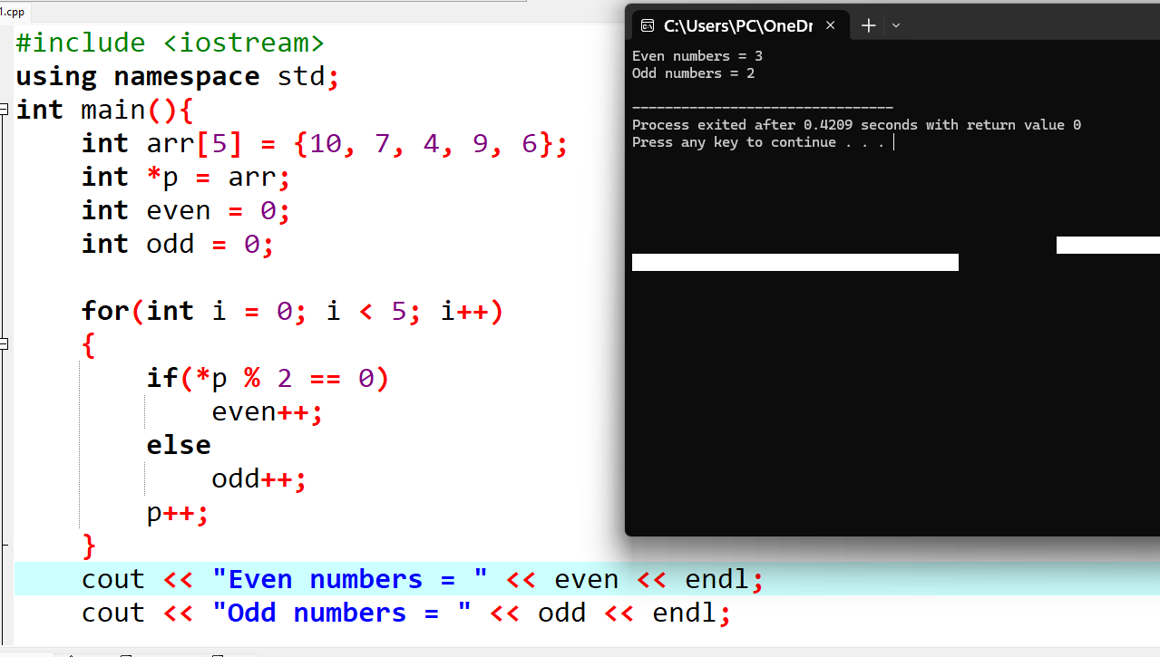
Task 2:

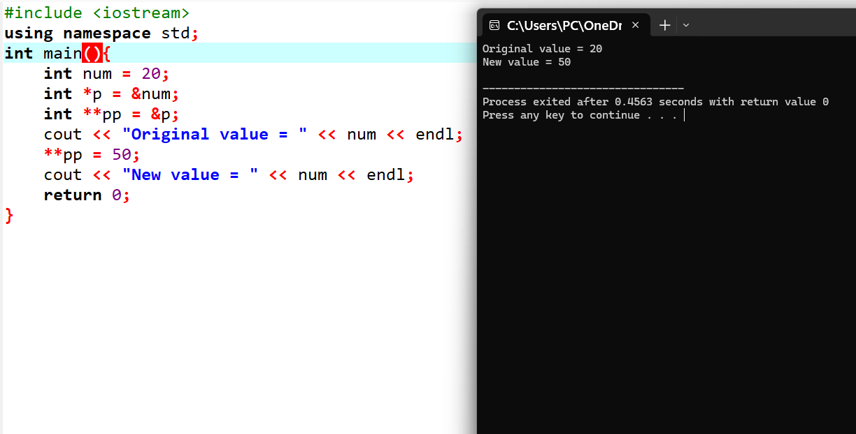

Task 3:


